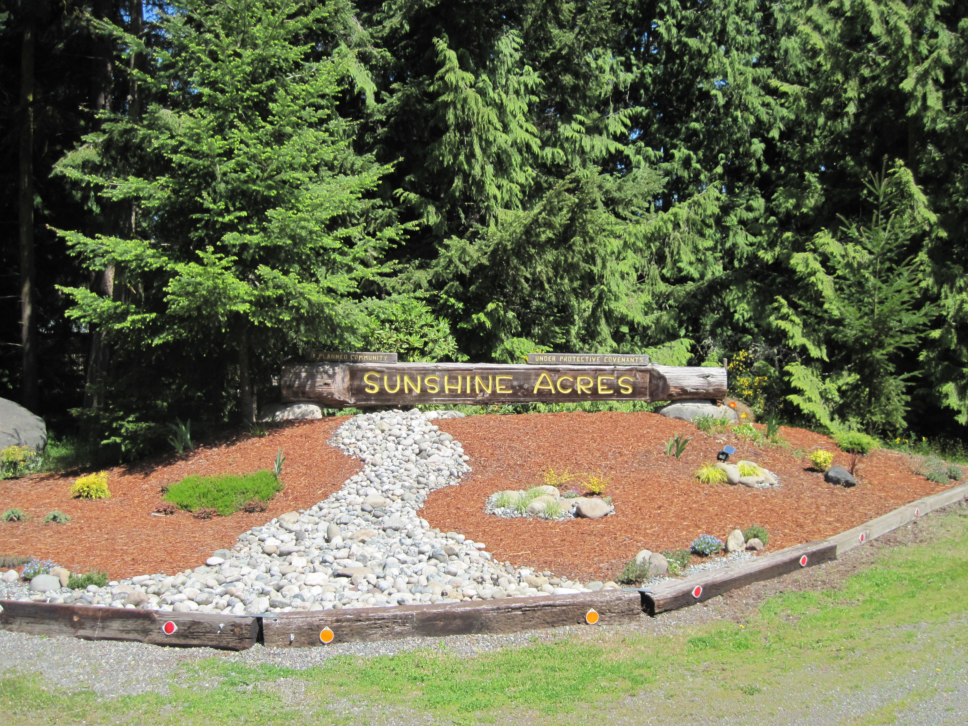
SAPOA NEWSLETTER
SUNSHINE ACRES PROPERTY OWNERS ASSOCIATION
P.O. BOX 824, SEQUIM, WA 98382
EMAIL: sapoasequim@olypen.com
WEBSITE: http://sites.google.com/site/sapoasequim

JULY 2015
This newsletter is sent to all property owners of Sunshine Acres in the interest of greater awareness and understanding of events and happenings in our community. It is funded by SAPOA annual dues.

PRESIDENT’S MESSAGE  With the new by-laws change there will not be a Budget Ballot this year because there is NO change to the Budget (see attached).  We need volunteers for the Board. We have people who reached their term limits and can no longer run. If you are interested, please contact a current member of the Board for information on the nomination process. See Nominations form attached.  In April we had a small slide on the upper west side of Mussel Beach Road. Temporary repairs were completed very quickly and permanent repairs with new culverts were completed the end of May. The Clallam County Planning Department was notified and all rules followed.  Our next general meeting is September 19, 2015. Come out for coffee and cookies at 12:30 p.m. and the meeting at 1:00 p.m. This is a chance to meet your neighbors and let the Board know your input on how SAPOA should operate. If you can’t attend but would like to give your proxy to another member of SAPOA, please use the proxy form attached.  Two of our newsletters require that we send them First Class Mail but the others can be sent by e-mail. If you would like to receive the newsletters or any other information by e-mail, please send us your e-mail address (if you haven’t already done so) to sapoa@sapoasequim.com or to Marty Tipton at mtip10@olypen.com.  Thank you. Everett Stauffer | SAVE THE DATES 2015  Board Meetings  9:00 a.m. at the Fire Station  September 10, November 5  General Meetings  1:00 p.m. at Gardiner Community Center  Highway 101  September 19, 2015  Current 2015 OFFICERS & DIRECTORS  Everett Stauffer President 360-681-5170  Gordon Tubesing Vice-President 360-683-0108  Lynette Will Corresp. Sec. 360-460-4193  Ginny Wilken Recording Sec. 360-582-0688  Marydee Countryman Treasurer 360-683-7540  Jerry Stiles Director 360-683-7080  Kathleen DeStefano Director 360-683-0722  DUES ARE DUE:  $50 annually. Per Section 2.4 of the By-Laws, we do NOT send out invoices for the dues. Notices are put in the newsletters. Only when you are overdue will invoices be sent. Dues are due by September 1st of each year and become delinquent on October 15. Make checks out to SAPOA and mail to P.O. Box 824, Sequim, WA 98382.

Diamond Point Airport will celebrate its 50th Anniversary on Saturday, August 8, 2015, from 10 a.m. to 2 p.m. Refreshments will be served from 11a.m. to 1 p.m. Events include aircraft flyovers; car show; local aircraft display; and door prizes. Drawings based on ticket sales will begin at 11a.m. Diamond Point Airport Association logo-wear will be available. Where: Airfield area at corner of Sunshine Ave and Flight Alley. If you have any questions, contact Gordon Tubesing 683-0108.
Absentee owners: If you own property in Sunshine Acres but do not physically live here and your property is not rented out to other parties, please make an effort to meet your neighbors and share contact information. This way if there are issues regarding your property (unknown parties occupying, etc.), authorities can be contacted on your behalf if needed.
BURN BAN - FIRE DANGER
I imagine everyone is aware of the increased fire danger this summer with the drought in Clallam County. A complete burn ban was instituted in the last weeks of June earlier than the usual July 1 start. This year the Office of Community Development in coordination with the Department of Natural Resources has called for a burn ban that excludes all outdoor burning. This includes recreational campfires and even charcoal briquettes in your barbecue. Propane barbecues are allowed.
Keep the grass on your property cut short. A fire in short grass will creep. A fire in tall grass will expand to an acre or more in minutes. If you park in dry grass and keep your car engine running for several minutes, the heat from your muffler can catch the grass on fire and burn your car and maybe you, too. Let's be especially careful out there, folks.
Unless we get substantial, cool, wet weather, the burn ban will continue through to October 1 and if we get no wet weather the ban will proceed beyond into the fall.
Marydee Countryman,Volunteer Fire Captain, Diamond Point, Gardiner

2015-2016 APPROVED BUDGET
CATEGORY | 2015-2016  APPROVED BUDGET | 2014-2015  BUDGET | % of Dues Budgeted to Projected Dues | Dues Allocation to Budgeted Expenses per Owner
Member Communication | $ 3,000.00 | $ 3,000.00 | 15.04% | $ 7.52
(includes Newsletter, Ballots, meeting room and supplies, Web site costs, postage, post office box fee and office supply costs)
Storage Facility | $ 275.00 | $ 275.00 | 1.38% | $ 0.69
Professional Services
Insurance | $ 6,500.00 | $ 6,500.00 | 32.58% | $ 16.29
Bookkeeping/Recordkeeping | $ 2,000.00 | $ 2,000.00 | 10.03% | $ 5.01
Taxes, filing fees and assessments | $ 250.00 | $ 250.00 | 1.25% | $ 0.63
UNREIMBURSED Collection Costs | $ 150.00 | $ 150.00 | 0.75% | $ 0.38
Retention Pond O&M Restricted Funds Allowance | ** Reserved Funds Maximum of $5,000 has been reached
Common Properties Maintenance Fund | $ 1,455.00 | $ 1,455.00 | 7.29% | $ 3.65
Plat Architectural Supervision | $ 100.00 | $ 100.00 | 0.50% | $ 0.25
Emergency Fund Expenses | $ 220.00 | $ 220.00 | 1.10% | $ 0.55
MBR RESERVE FUND CONTRIBUTION | $ 4,000.00 | $ 4,000.00 | 20.05% | $ 10.03
EMERGENCY/LEGAL RESERVE FUND CONTRIBUTION | $ 2,000.00 | $ 2,000.00 | 10.03% | $ 5.01
TOTALS | $ 19,950.00 | $ 19,950.00 |  | $ 50.00

SAPOA BOARD OF DIRECTORS
NOMINATING FORM

I would like to nominate (myself) (other) to the SAPOA Board of Directors for terms beginning January 2016
Name of Candidate
Address of Candidate
City State and Zip
Telephone Number
Email

Contact for Nominator if Not Candidate:
Name:
Address:
Telephone Number:
Email:

Bio of Nominee (Self) (Attach sheet if necessary):

(Signature Nominator):

(Signature Nominee if Applicable):
Mail to SAPOA, P.O. Box 824 Sequim, WA 98382.

SUNSHINE ACRES PROPERTY OWNERS ASSOCIATION
GENERAL MEETING PROXY

IMPORTANT: Please make sure that the party to whom you give your proxy is going to be attending the General Meeting. Also, give that person this Proxy form; DO NOT mail to SAPOA.

___________________________________________________SHALL HOLD MY PROXY FOR THE GENERAL MEETING DATED: _____________________________________.

THIS PROXY IS VALID ONLY FOR VOTES OF GENERAL BUSINESS (Minutes and Audit approval) AND TO ACQUIRE A QUORUM FOR SAID BUSINESS.

__________________________________________________________________________________
Signature

Printed Name

Date

By-Law changes which were voted and approved in 2014 included the right to vote by Proxy at General Meetings. This was voted in to allow the members of SAPOA to conduct business at the General Meetings. Any votes of substance (road maintenance, dues, etc.) will still be done by a vote of the entire membership of SAPOA and done by mail. The above form is the required Proxy form to be used. If you are unable to attend the General Meeting, but want to make sure your voice is heard and are a member in good-standing (i.e., your dues are paid in full), please give your Proxy to a member of this community who will be attending the meeting to vote in your place. The member to whom you give your Proxy must also be a member in good-standing of SAPOA (i.e., dues are paid in full). If you have any questions regarding this matter, please contact a Board member.

SAPOA
P.O. BOX 824
SEQUIM, WA 98382

PLEASE READ THIS NEWSLETTER.
IT CONTAINS INFORMATION RELEVANT TO YOUR ACCOUNT AND YOUR COMMUNITY

