SAPOA NEWSLETTER

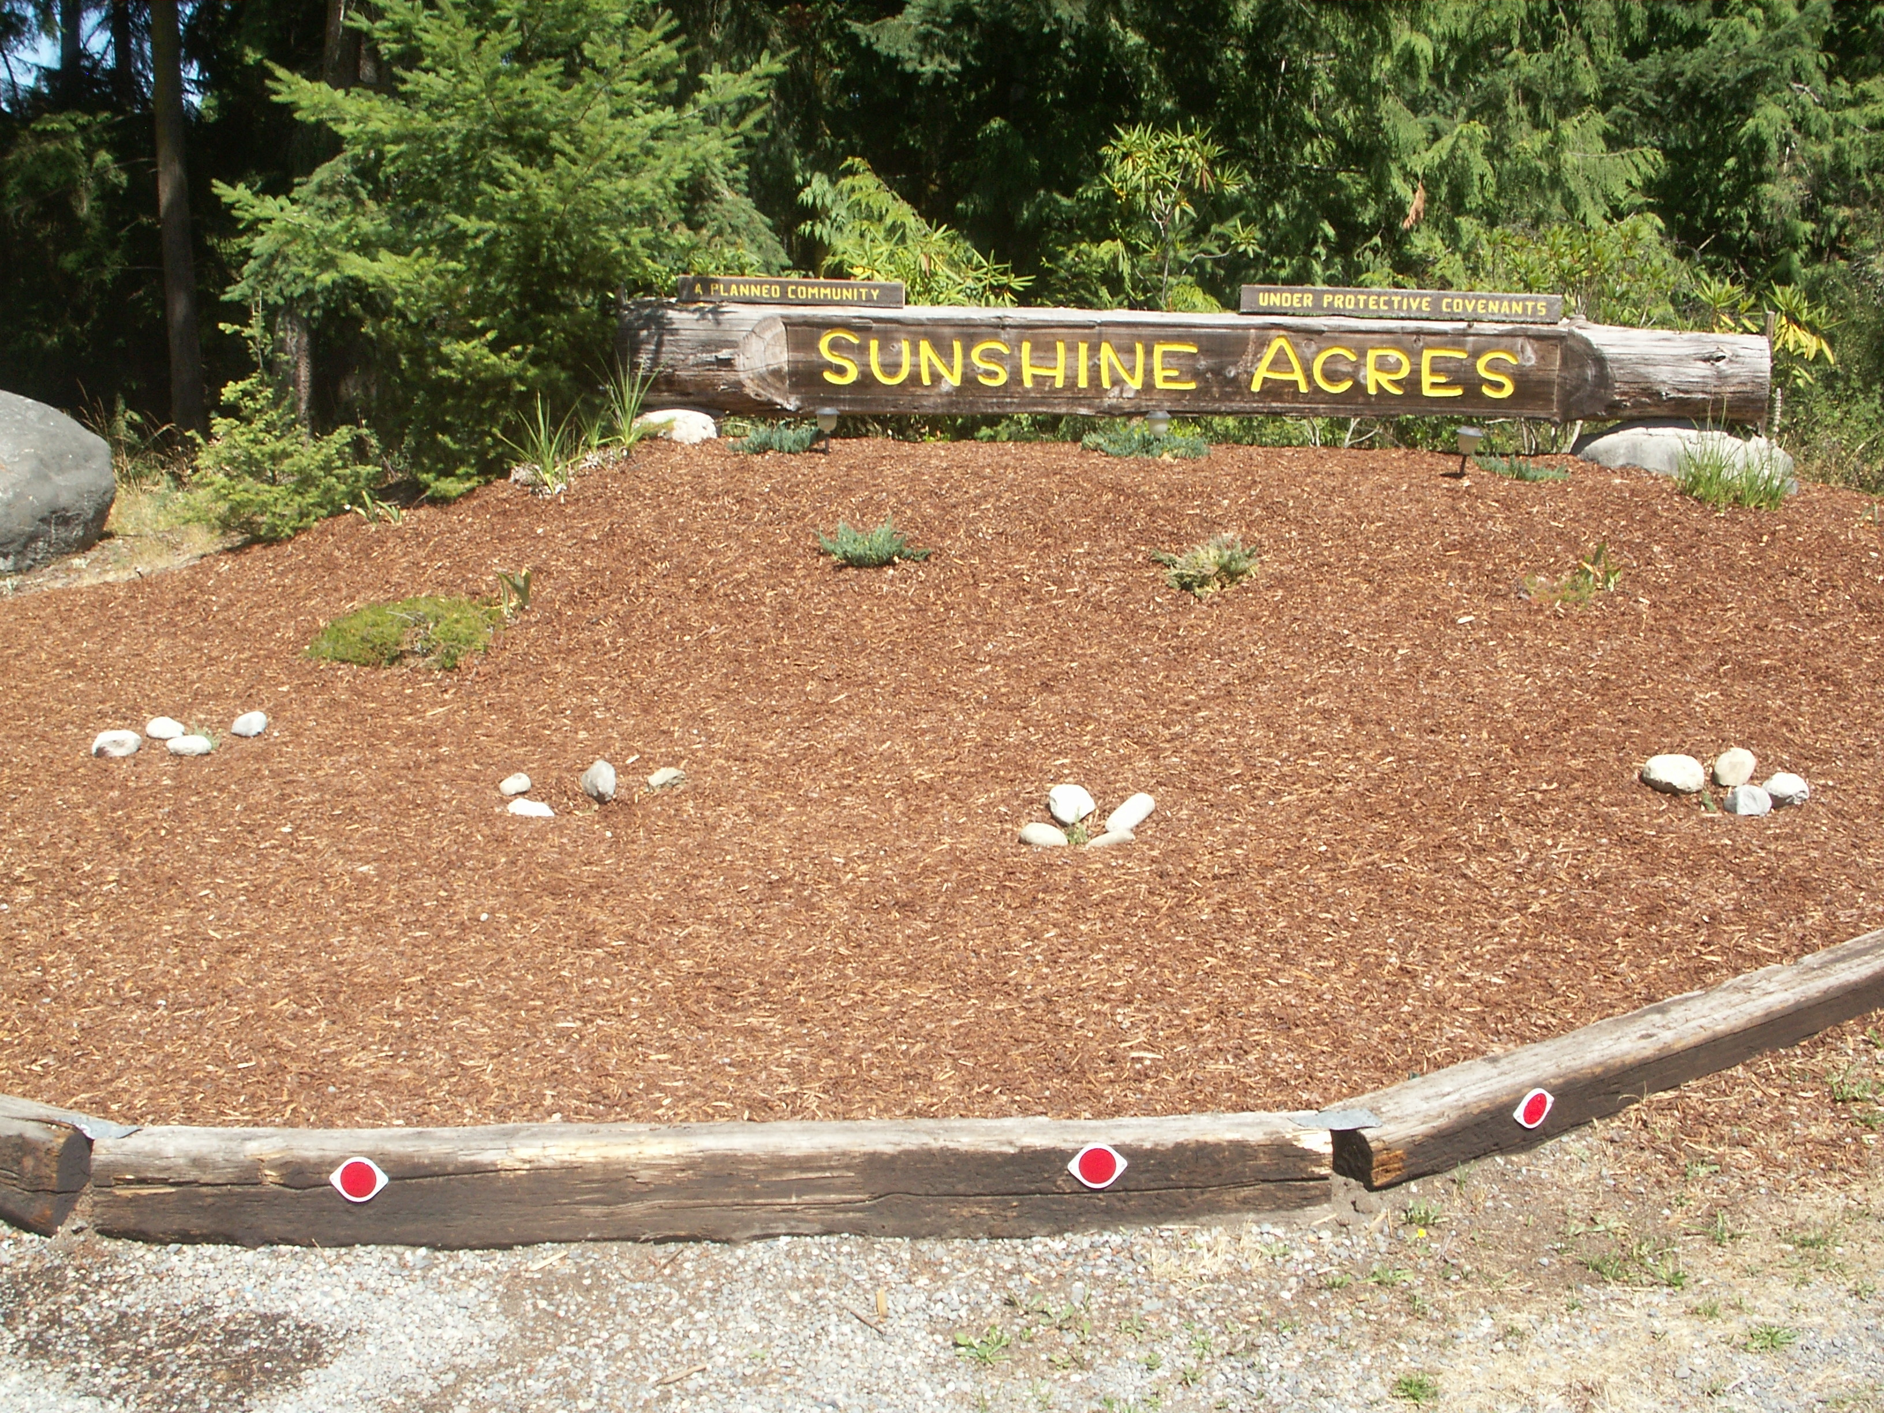

SUNSHINE ACRES PROPERTY OWNERS ASSOCIATION

P.O. BOX 824, SEQUIM, WA 98382

EMAIL: [sapoasequim@olypen.com](mailto:sapoasequim@olypen.com)

WEBSITE: <http://sites.google.com/site/sapoasequim>

**July, 2019**

*This newsletter is sent to all property owners of Sunshine Acres in the interest of greater awareness and understanding of events and happenings in our community. It is funded by SAPOA annual dues. To REDUCE annual due increases, please provide your email address to Cecilia Eckerson, it costs over $1400.00 annually to send paper newsletters.*

|  |  |
| --- | --- |
| **PRESIDENT’S MESSAGE**  My name is David Wescott, I am the President of SAPOA, I hope that you all are having a great summer.  We are looking for anyone in the community who may have quick books experience or knowledge. If you have this experience please call me at the below number.  This summer is very dry please mow your lots to reduce the fire hazard.  The beach road and common areas are in great shape, please use and remember to be mindful of neighbors.  Next door is a great place to communicate with neighbors.  Remember the association does not get involved in civil disputes or claims.  Airport Appreciation Day is on August 10th 2019.  Thank you.  ***David Wescott*** | **SAVE THE DATES**  **Airport Appeciatoin Day**  Saturday, August 10th  9:30am. Helipad Community Dedication  10am-2pm $5 lunches; $60 Helicopter Ride; prizes; airplane and car displays  **General meetings at the**  **Gardiner Community Center**  **September 28, 2019**  **Social Time: 12:30pm**  **Meeting: 1:00 p.m.**  **Proxy Forms are available on line**  **Current 2019 OFFICERS & DIRECTORS**  David Wescott President 206-790-2510  Loren Erpelding Vice-President 360-681-8566  Cecilia Eckerson Treasurer. Sec. 360-808-0709  Kaye Gagnon Correspondence 310-654-3441  Lynnette Will Secretary 360-775-8896  **We need a Quick Book or Accounting and Member Data Base Volunteers to keep our Annual Dues as Low as possible** |
| **Community Reminder:**  **Before Burning Check for Burn Bans**  **Please take care in any recreational fires that you may have during this dry season.**  **FOR MORE INFORMATION:**  **https://ccfd3.org/** | **$50 ANNUAL DUES ARE PAYABLE 9/1/2019 - Please submit to:**  **SAPOA, PO 824, Sequim, WA 98382**  **(Please include property address)**  Per Section 2.4 of the Bylaws, we do not send out bills for the dues. **Dues are due by September 1st** of each year and become delinquent on October 15. Only when you are overdue will bills be sent. Liens are placed when 2 or more years are owed. |

**Community Reminder Continued:**

Per the rules and regulations owners are not allowed to live in motor homes on their properties. So please follow the rules. Also please keep your properties looking nice. Curb appeal is important for all of us in the community. Please help keep our community looking beautiful.

The SAPOA Board Meeting on 7/15/2019 included the following highlights, for complete meeting minutes, see the SAPOA website.

The need for upgrades to the SAPOA accounting system will cause dues to increase significantly if we cannot find a volunteer to manage member emails, profit and loss statements, balance sheets and aging statements, monthly reconciliations.

The Board is soliciting estimates for Accounting and Financial Management from a number of local businesses if volunteers do not step forward. Quotes will be obtained from Bell & Futch and others as a means to ensure we can keep our operating costs as low as possible.

The SAPOA Board is looking an additional Board member. If interested please reach out to any Board member for more information.

**We look forward to meeting you on:**

**September 28th  12:30**

**at the Gardiner Community Center!**